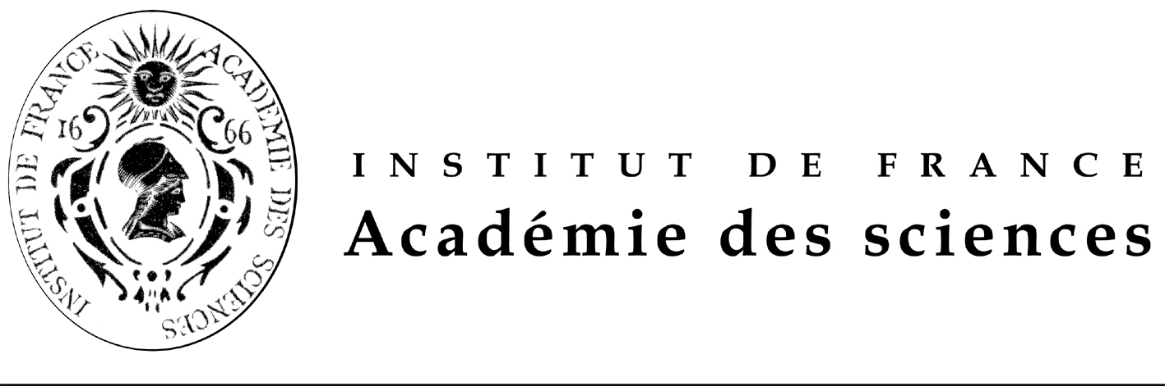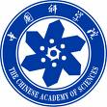

FONDATION FRANCO-CHINOISE POUR LA SCIENCE ET SES APPLICATIONS (FFCSA)
POST-DOCTORAL FELLOWSHIPS OFFERED

PROMOTION 2013
(18 months or 24 months)

Call for candidates: September, 28th, 2012.

FFCSA’s Fellowships are awarded for 18 months or 24 months.
They are exclusively aimed at candidates living in mainland China who wish to come to France. Chinese scholarship holders currently in France who are seeking to extend their stay are not eligible to apply.

Fellowships offered are aimed exclusively at post-doctoral scholars, who have obtained their Ph.D. before the end of December 2012 and within the last 6 years and are under 35 years of age. A fluent knowledge of English is a pre-requisite for admission.

Selection of candidates is a three-stage process:

- call of offers, and short-listing of candidates in China, under the guidance of China Scholarship Council (CSC) and the Chinese Academy of Sciences (CAS) which select three times as many candidates as there are fellowships on offer;

- interviews in China, in Beijing and Shanghai, by an FFCSA expert panel from France (candidates’ travel costs to the interview locations are at the candidates’ expense);

- Final decision in France by the FFCSA’s Scientific Council on the candidates selected and on their host laboratories in France, with the confirmation of CSC and the CAS.

The timetable for the fellowships promotion 2013 award is as follows:

  - September 28th, 2012: Call of proposal publication in French, English and Chinese of the Fellowships offered for promotion 2012;

  - December31st , 2012: deadline for applications in China and in France;

  - From January 7th 2013 to January 12th 2013: interviews of short-listed candidates in Beijing or Shanghai by examinators send by the FFCSA; ranking of candidates for each fellowship offered;

  - From February 11th 2013 to February 28th 2013: final decision on candidates selected by the FFCSA’s Scientific Council, with the confirmation of CSC and the CAS; candidates selected will be immediately informed and will be required to start learning French intensively before leaving China (French training lessons in charge of the CSC).

  - March-July 2013: French training lessons in China.

  - September- October 2013: arrival in France of candidates selected.

The international plane fare from China to France and return is taken in charge by the CSC. The travel cost to provincial France when necessary will be covered by the FFCSA. The total amount of the fellowship is € 2 500 net per month. The cost of health insurance is covered by the FFCSA.

Whichever the date corresponding at research work during the fellowship, publications should mention imperatively the help of the FFCSA and CSC.

During his/her stay in France, each scholar will be counselled by the FFCSA whose task is to ensure the harmonious integration of the scholar and the smooth development of his/her research programme. The scholar’s return to China is mandatory. FFCSA had created an Alumni Club in January 2005.

For the class 2013, 18 months or 24 months, beginning September-October 2013, fellowships offered are in the following subjects in the laboratories selected by the FFCSA:

- The roles of the death receptors in cancer biology, with the focus on the Fas/CD95 signalling in the control of life and death of cells in relation to cancer therapies
(The post doctoral fellow will participate in ongoing studies in this context and will be particularly focus in the design and the functional screening of agents (peptides) that modulate Fas signaling by targeting the intracellular multifunctional control of Fas.).
- The roles of the death receptors in cancer biology, with the focus on the Fas/CD95 signalling in the control of life and death of cells in relation to cancer therapies
(The post doctoral fellow will participate in ongoing studies in this context and will be particularly focus on the generation of targeted technological approaches.).
- Cognition research, functional RMN of the brain and neuroeconomics, decision making and incitive process.
- Crystals of Crystals.
- Chemistry (synthesis, conception) of stapled peptides.
- Analysis the data produced by the latest generation of sequencing and genotyping technologies (developing algorithms in a large-scale environment and computer science in general).
- Analysis the data produced by the latest generation of sequencing and genotyping technologies (Statistics with interests and skills in developping new statistical methods, Systems biology).
- Molecular and genetic characterization of a gene pathway associated with Double Flower phenotype in Roses.
- Function and regulation of the Translationaly Controlled Tumor Protein (TCTP), a conserved mitotic growth integrator in animals and plants.
- How important and diverse is “green” picoplankton (Prasinophytes) in oceanic waters.
- Dye-sensitized solar cell, semiconductor nanocrystals, quantum dots, organic/inorganic hybrid materials, transport measurements, semiconductor nanowires.
- Serine, threonine and tyrosinekinase in bacteria.
- Genetically modified mesenchymal stem cells expressing on-demand physiological MMP inhibitors in corneal wound healing: from cell to gene therapy.
- Elasto plastic fracture mechanics, limit analysis
- Brittle and ductile fracture, low cycle fatigue
- Numerical welding simulation. Thermomecanics
- Atomics physics
- Quantic optics
- Nanophotonics
- Models of Human body and biotechnologies: Science, technology , ethics and culture
- Optical components for attosecond pulses.
- A theoretical treatment of the temporal excitation of nanoresonator modes.
- Numerical modelization of the rheology of suspensions, biomimetic matter and blood.

IMPORTANT
If the applicant chooses 2 thematics, he /she has to give his/her preference whether A or B
Candidates application’s package should include (see the application form):
-a detailed CV,
-a motivation letter pointing out either the suitability of your CV,
-the scientific publications,
-the research grants,
-and two letters one from the head of the laboratory and one from the President of their University or from a Science Academician if he or she is not working in a University.

Candidates should send their application package by e-mail at all the following addresses ffcsa@academie-sciences.fr and yzhang@csc.edu.cn and xflu@cashq.ac.cn

The deadline is December 31st , 2012. Applications should be send in parallel by mail to Mme ZHANG Ying, Project Officer, Division of Cooperation and Consultancy, China Scholarship Council,9-A3 Chegongzhuang street Beijing 100044, P.R.China , e mail : yzhang@csc.edu.cn .

The China Scholarship Council will inform the FFCSA and the Chinese Academy of Sciences of the progress timely.

Chinese version and forms are available at URL: http://www.cas.cn,
the post-doctoral fellowships offered is also available at URL http://www.csc.edu.cn and French and English versions are available at URL http://www.academie-sciences.fr/activite/inter.htm and http://www.ffcsa-club.org/fr/newscenter.html

